NAME: B.SAI NATH ROLL NO: 2403A510C3
LAB ASSIGNMENT 2.1:
TASK 1:
Code:
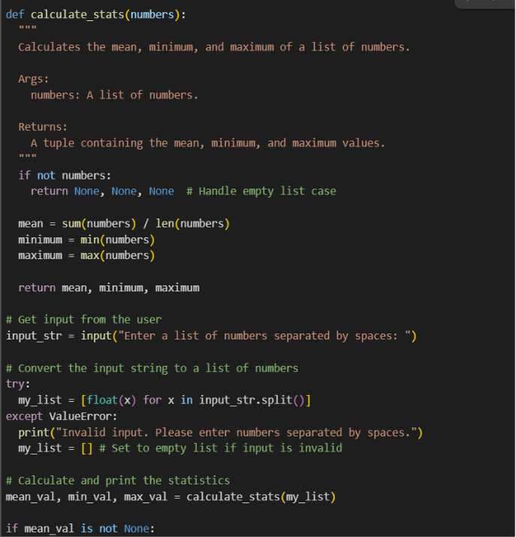
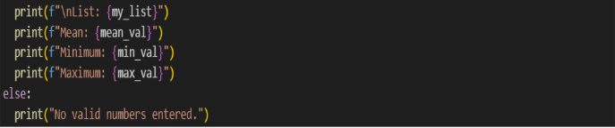
OUTPUT:
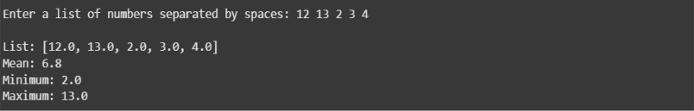

OBSERVATION:
Observation: The code correctly handles empty input and invalid values, making it user-friendly. It also demonstrates how built-in functions simplify finding mean, min, and max
ww
This Python code defines a function calculate_stats to find the average (mean), smallest (minimum), and largest (maximum) numbers in a list. It first checks if the list is empty; if so, it returns nothing. Otherwise, it calculates the sum and length to find the mean, and uses built-in functions min() and max() for the minimum and maximum. The code then prompts the user to enter numbers separated by spaces. It attempts to convert the input string into a list of floating-point numbers, handling potential errors if non-numeric input is given. Finally, it calls the calculate_stats function with the user's list and prints the resulting mean, minimum, and maximum values, or indicates if no valid numbers were entered.
TASK 2:
OUTPUT OF THE GEMINI:
OUTPUT OF THE CO PILOT:
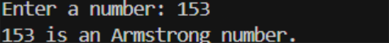
Side by Side Comparision:
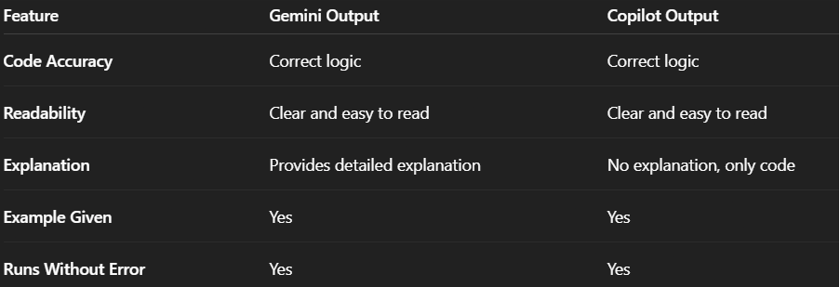
TASK 3:
THE FOLLOWING IS THE GEMINI EXPLANATION LINE BY LINE:
Let's go through the is_prime(n) function step by step:
- def is_prime(n):: This line defines a function named is_prime that takes one argument, n.
- """Checks if a number is prime.""": This is a docstring, which explains what the function does.
- if n <= 1:: This checks if the input number n is less than or equal to 1.
- return False # Numbers less than or equal to 1 are not prime: If n is less than or equal to 1, the function immediately returns False because prime numbers are defined as being greater than 1. The comment clarifies why.
- `for i in range(2, int(n0.5) + 1):**: This line starts aforloop. It iterates through a range of numbers starting from 2 up to the integer part of the square root ofn, plus 1. We only need to check for divisors up to the square root ofnbecause if a numbern` has a divisor greater than its square root, it must also have a divisor smaller than its square root.
- if n % i == 0:: Inside the loop, this line checks if n is divisible by the current number i using the modulo operator (%). If the remainder of the division is 0, it means n is divisible by i.
- return False # If divisible by any number in this range, it's not prime: If n is divisible by any number i in the specified range, it means n is not a prime number, so the function returns False. The comment explains this.
- return True # If not divisible by any number in the range, it's prime: If the loop finishes without finding any divisors (i.e., the function hasn't returned False yet), it means n is not divisible by any number in the range, and therefore it must be a prime number. The function then returns True. The comment clarifies this.
TASK 4:
CURSOR SETUP:
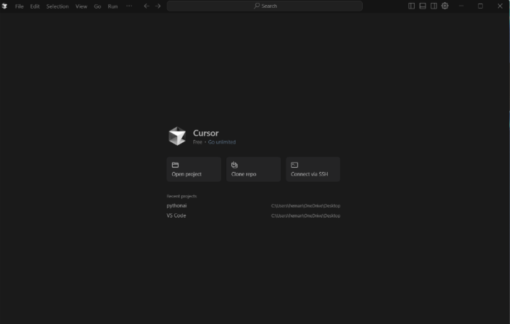

THIS GIVEN CODE IS FROM CURSOR:
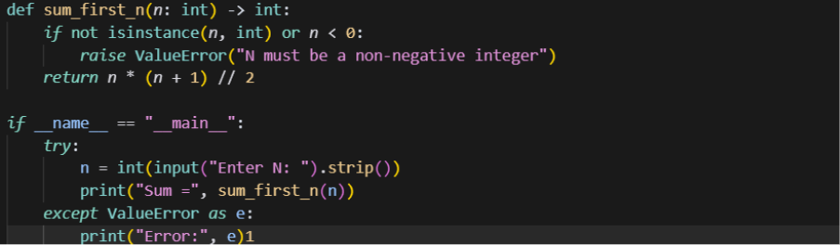
OUTPUT:
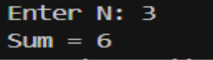
OBSERVATION :
The cursor setup and code demonstrate how AI-based coding assistants can generate functioning code quickly, but human verification is still needed to ensure correctness.

TASK 5:

TASK 5:
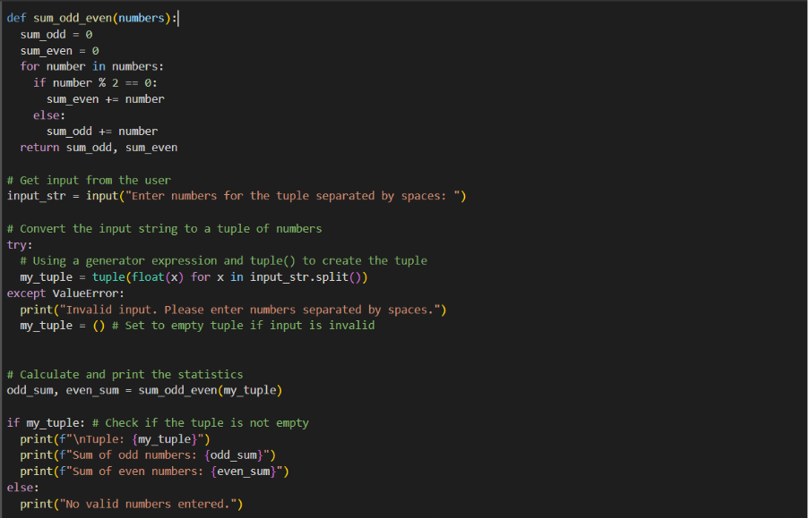
OUTPUT:
